JUnit_Basic Testing Exercises

Exercise 1: Setting Up JUnit

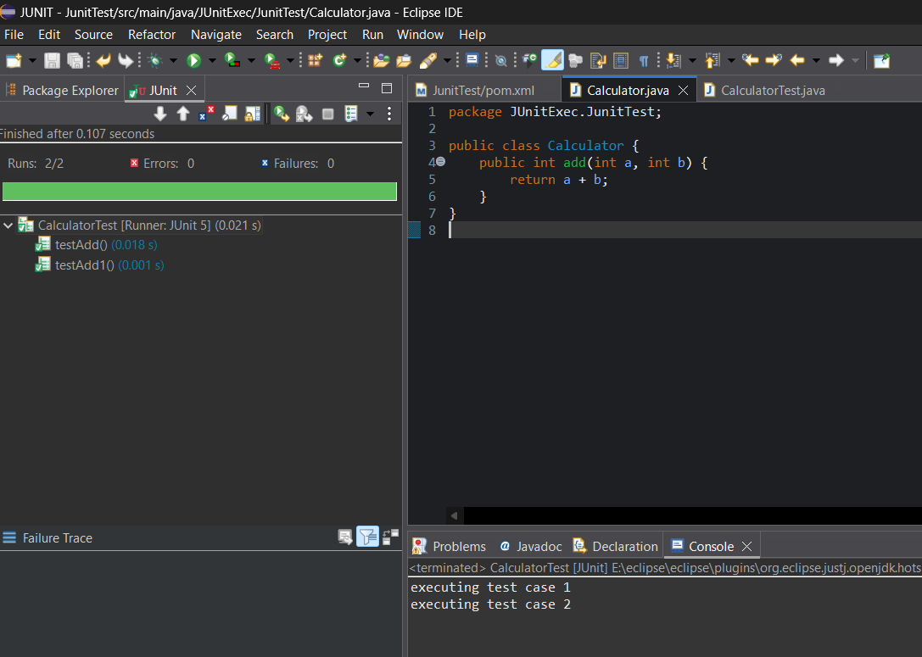

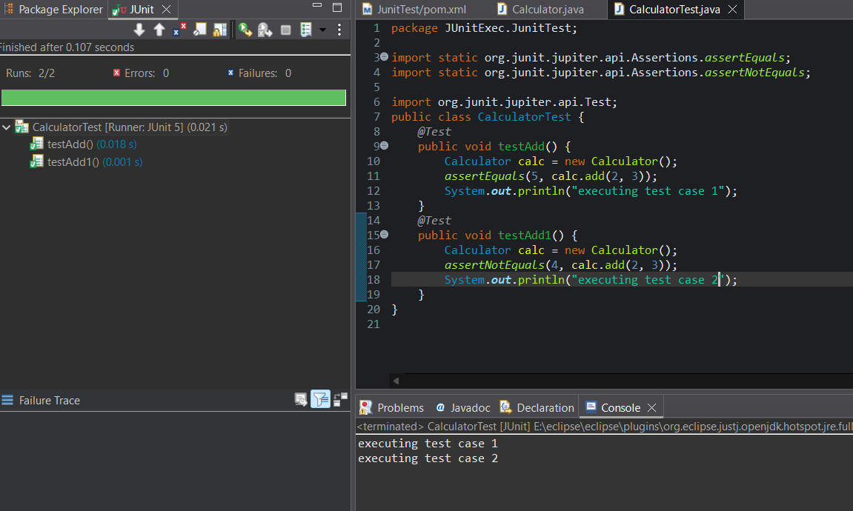

Exercise 3: Assertions in Junit

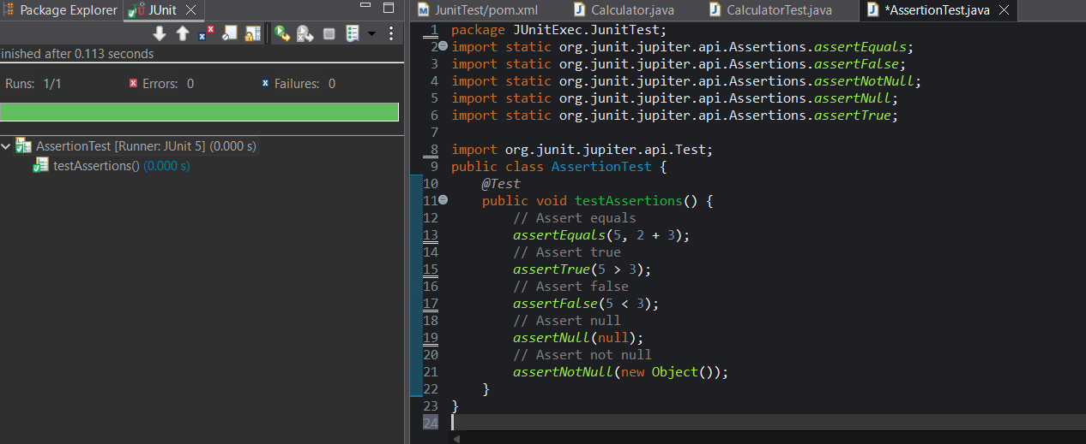

Exercise 4: Arrange-Act-Assert (AAA) Pattern, Test Fixtures, Setup and Teardown Methods in Junit

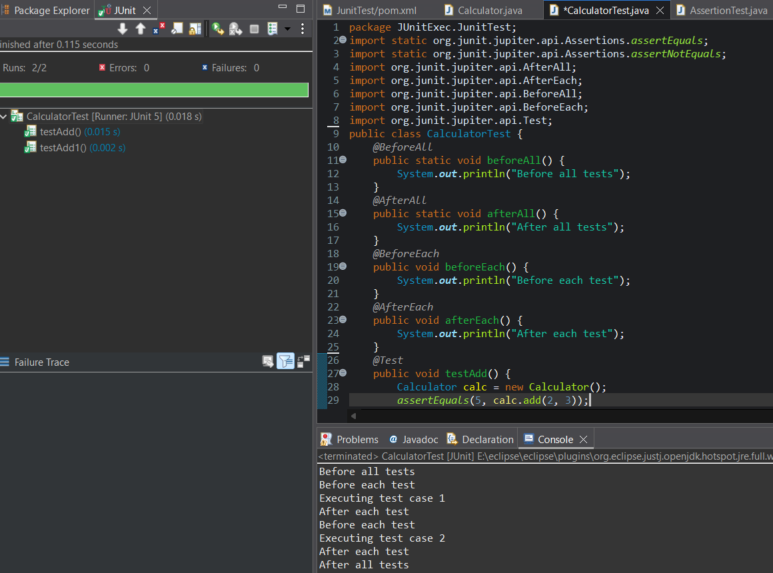

Mockito Hands-On Exercises:

Exercise 1: Mocking and Stubbing:

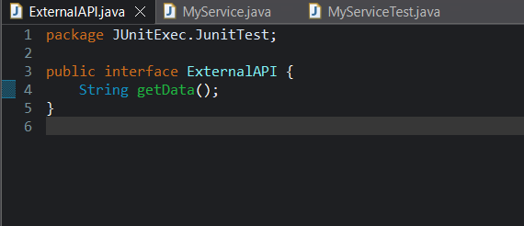

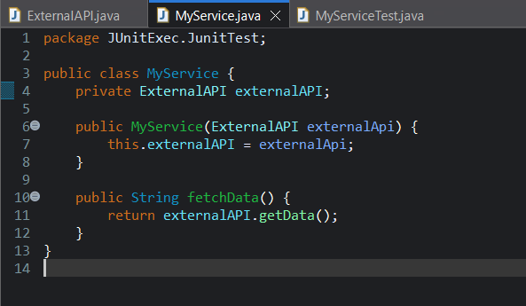

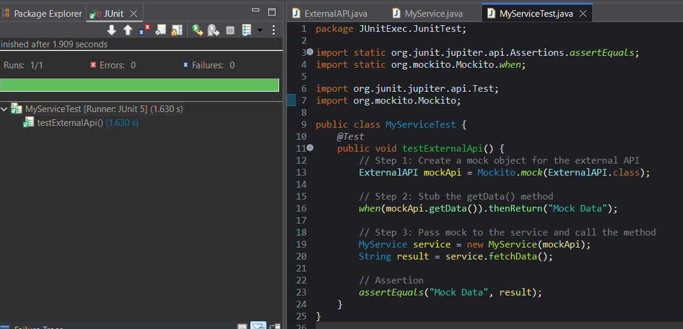

Exercise 2: Verifying Interactions:

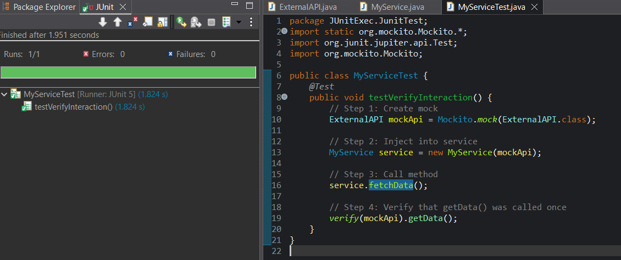

Logging using SLF4J:

Exercise 1: Logging Error Messages and Warning Levels:

